Sunday | Monday | Tuesday | Wednesday | Thursday | Friday | Saturday
 |  |  |  |  |  | April Fools Day 1
 |  |  |  |  |  | It’s April Fool’s Day! Celebrated all over the world as a morning of jokes and tricks.
World Autism 2 Day | Songs 3 | Play 4 | Math 5 | Science 6 | Good Friday 7 | Writing 8
Use Geologists Day as a chance to collect different kinds of rocks. | On Film Score Day, listen to music from popular movies and pretend you’re a part of the story. | Get out your favorite board game and invent a new set of rules with your child. | Label ten pipe cleaners with numbers 1–10. Have your child string the right number of beads onto each. | Take an ice cube out of the freezer and put it in a bowl. Talk about what’s happening. changes form. | Make up a silly song about the steps of a daily routine like getting ready for bed. | Get ready for Unicorn Day tomorrow by making paper unicorn horns for your child to color and decorate.  Easter Egg hunt and CWS event, Lowden Park
Unicorn Day 9  Easter Sunday | Siblings 10  Day | Math 11 | SONGS 12 | National 13 Scrabble Day | Sounds 14 | ART DAY 15
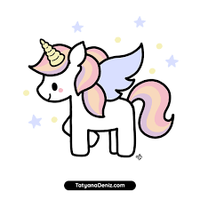  Unicorn day in Scotland. Don your unicorn horns. | Honoring the relationships of siblings. | Gather blocks and dice. Have your child roll the dice and stack the right number of blocks together. | Challenge your child to sing her favorite song by heart. | On Scrabble Day, use letter tiles to spell simple words and show how changing one letter creates a rhyming word. | Try to make each other laugh with different sounds and faces on Moment of Laughter Day. | It’s World Art Day! Pull out your craft supplies and make art for an at-home museum.
Sounds 16 | Haiku 17  Poetry Day | World 18  Heritage Day | Play 19 | Rhymes 20  Eid al-Fitr | Writing 21  Eid al-Fitr | EARTH DAY 22
Safety Day  Lewiston Fire Department | Talk to your child about where birds go during the winter month. Write a Hiaku. | Go on a walk and see how many Historical Plaque you can find. | Create your own zoo at home with stuffed animals or animal crackers. | Make up rhyming nicknames for each other and use them all day.  End of Ramadan | Have your child make a sign with her name on it using a different color for each letter.  End of Ramadan | In honor of Earth Day, try making homemade seed paper together
Shakespeare 23  Day | Song 24 | Play 25 | Reading 26 | Math 27 | Writing 28 | Rhymes 29
Turn your living room into a movie theater. Invite all your child’s stuffed animals to attend a screening. | Work together to add more verses to a song like “The Wheels on the Bus.” | Are you getting some April showers? Get outside and play in the puddles! | On Pretzel Day, share the alphabet book David’s by Helen Holder Pretzels. | Use colorful candies to practice simple math problems. | Make puppets out of brown paper lunch bags and put on a puppet show. | Write a rhyming poem with your child. Tuck it into her pocket for Poem in Your Pocket Day.
International 30  Jazz Day | 31
On International Jazz Day, listen to some kid-friendly jazz. Feeling inspired? Make some of your own music together.

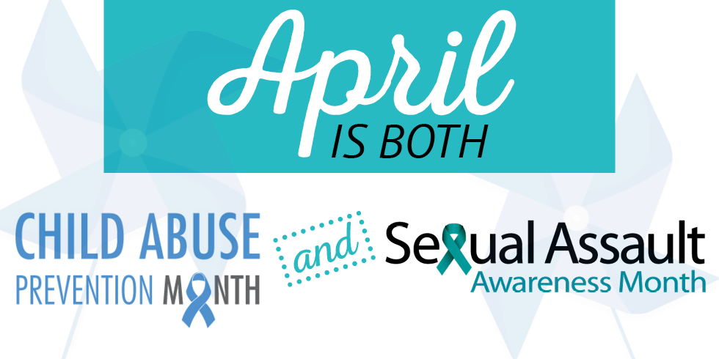

Resources | 530-623 2024 or 800-358-5251
Human Response Network
Behavioral Health | 530-623-1362 or 888-624-5820
(Mental Health & alcohol & drug services)
Child Protective Services | 530-623-1314 or 800-851-5658
Health and Human Services | 530-623-1265 or 800-851-5658
Trinity County Grants & Housing | 530-228-7811
Public Health | 530-623-8209
24 Hour Crisis Lines
HRN (Domestic Violence and Sexual Assault) | 530-623-HELP
Trinity County Behavioral Health | 530-623-5708

IS THERE A MAGIC WAND?
Wouldn’t it be great if with one brisk wave of a wand and “Bingo” your child does
everything you want. There is no magic wand but maybe there will be magic in one of the
choices below.
- Take out the “No”
“Feel free to go out and play when your toys are picked up.”
- Offer a choice
“Would you like to wear a sweatshirt or sweater?”
- State what you are going to do rather then what the child should do. “I’m serving dinner in five minutes.”
- Write a note/draw a picture
“I’m hungry. Please feed me.” on top of the clothes hamper does wonders.
- Make it a game.
“Let’s see if all the cars can be in the toy box by the count of 10.”
- State how you feel.
“I get angry when someone uses my things without asking.”
- Give them information
“Coats need to be hung on the hooks.

